Input, output and Devic

05-09-2022 / Mondey

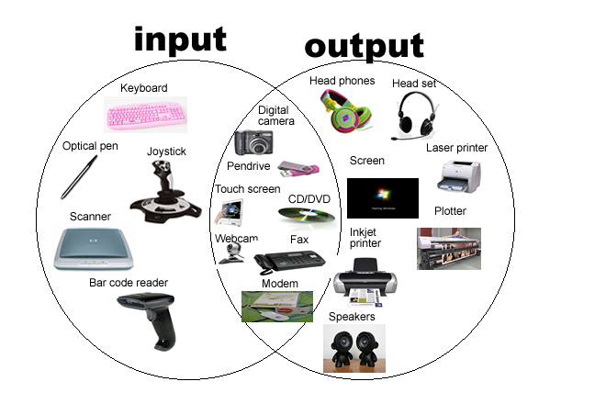**Device**: Engels term voor 'apparaat'.

* **Examples :** Telephone, Laptop and Printer.

**Input Device**: connected to accept date from users. Its controlled by users.

* **Examples :** Mouse, Keyboard, Mic and Scanner.

**Output Device**: connected to provide information to users. Its controlled by the computer.

* **Examples :** Printer, Speaker, Headphones and GPS.

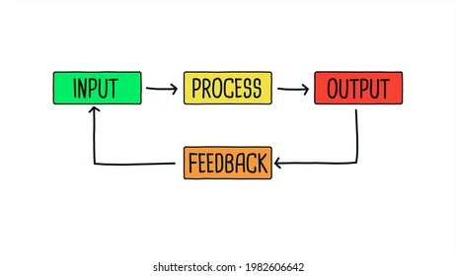

**Float :**  is **a variable type that is used to store floating-point number values**.

* **Examples** of floating-point numbers are 1.23, 87.425, and 9054.2.

